**RESTful services used to publish website**

REST works almost exactly like a website in a browser. A resource is exposed to a program via a URL. The program can access that URL and receive data about the resource, not unlike when you type in a URL to your browser and get a web page back. Well designed RESTful APIs include additional links the program can follow to request related information - similar to how you would click on a link to visit a new page - or to submit data to update the given resource - similar to how you would fill out a web form to create a new account for a web site.

RESTful systems typically, but not always, communicate over [Hypertext Transfer Protocol](https://en.wikipedia.org/wiki/Hypertext_Transfer_Protocol) (HTTP) with the same [HTTP verbs](https://en.wikipedia.org/wiki/HTTP_verbs) (GET, POST, PUT, DELETE, etc.) that web browsers use to retrieve [web pages](https://en.wikipedia.org/wiki/Web_page) and to send data to remote servers.

**RESTful Web Service End Points :** 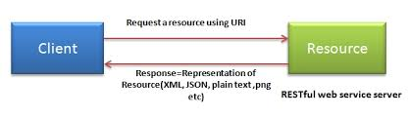

***Creating a setup to test REST API***

1. Copy CMND_ smart cms folder in the system. (please find the attachment for the folder)
2. Open the folder and double click on create db windows batch file
3. Provide the password
4. Copy war file from the folder CMND_ smart cms to the location (C:\Program Files\Apache Software Foundation\Tomcat 8.0\webapps)
5. Restart Apache and tomcat services
6. Open link <http://localhost:8080/smartcms/> in Mozilla browser (Note : it will show blank)
7. Install HTTP Requester Add-ons in Mozilla browser

***Commands for reference*** **URL :** <http://localhost:8080/smartcms/>

|  |  |  |  |
| --- | --- | --- | --- |
| **#** | **URI** | **Method** | **Description** |
| **1** | **/website/list** | **GET** | **Returns a list of all the websites** |
| **2** | **/website/{id}** | **GET** | **Return the website based on the id** |
| **3** | **/website/{id}** | **PUT** | **Update content based on id** |
| **4** | **/website/{id}** | **DELETE** | **Delete the issuer in the data store based** |
| **5** | **/website/add** | **POST** | **Inserts the website into the data store based on the contents of the json** |
| **6** | **/download/{id}** | **GET** | **http://localhost:8080/smartcms/download/{id}** |
| **7** | **/upload/{id}** | **POST** | **http://localhost:8080/smartcms/upload/{id}** |

***Tested publishing of website using RESTful services and below is the observation:***

### Description : Publish a website

### URL : http://localhost:8080/smartcms/website/add

### Method: POST

### Result : **PASS**

For example : use this sample code and copy paste in the content section and click on post: {"id":12,"nid":105,"orientation":0,"title":"Website12","folderName":"landscape","thumbnail":"page-7920-2.png","created":"2016-08-06T16:04:28+02:00","changed":"2016-08-06T16:05:28+02:00","publishDate":"2016-08-04T16:08:28+02:00"}

Please refer the attachment below:

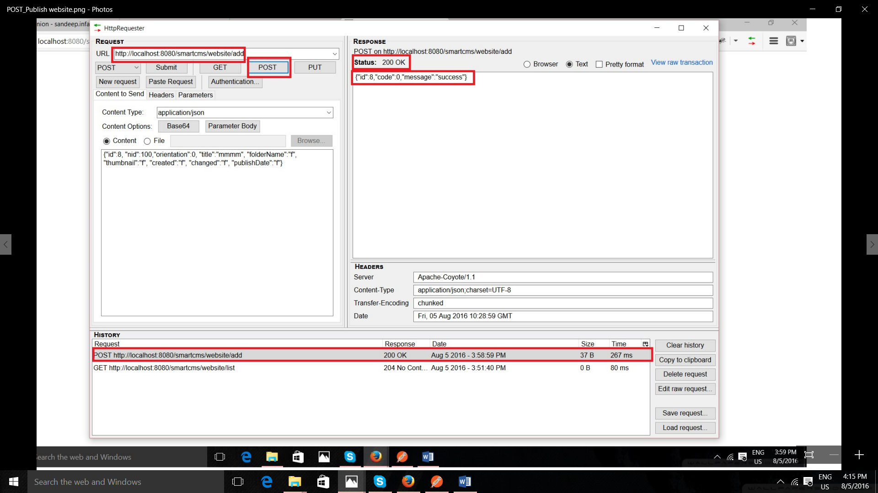

### **Description:** Get list of all published websites

### URL : http://localhost:8080/smartcms/website/list

### Method : GET

### Result: **PASS**

Please refer the attachment below:

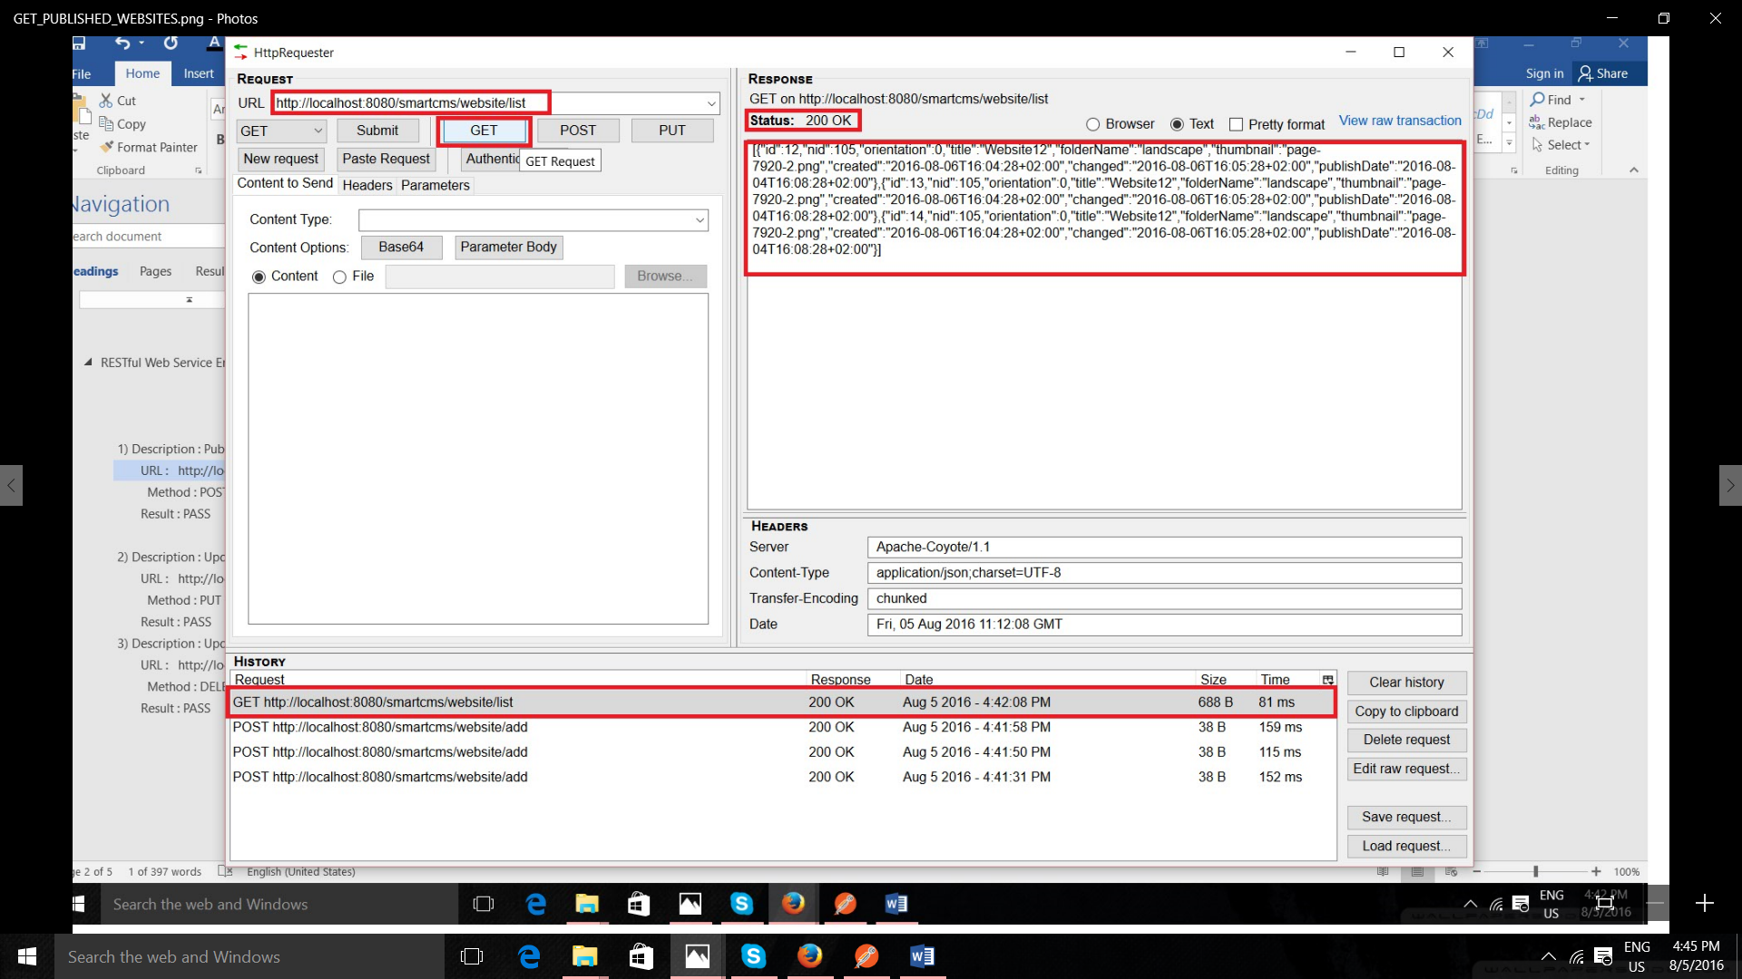

### **Description :** Update content of published website

### URL : http://localhost:8080/smartcms/website/12

### Method : PUT

### Result : **PASS**

Please refer the attachment below:

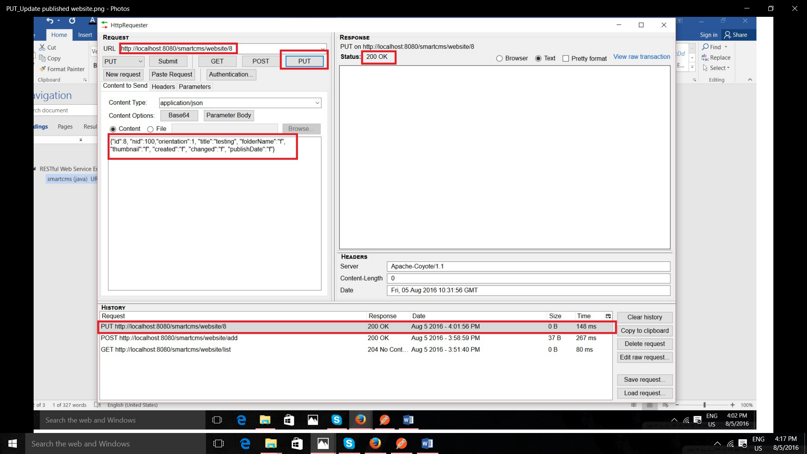

### **Description :** Update content of published website

### URL : http://localhost:8080/smartcms/website/12

### Method :DELETE

### Result : **PASS**

Please refer the attachment below

